LC/MS metabolomics in diagnosing and treatment of rare diseases (Calibri 12, bold)

David Friedecký^{1,2}, Radana Karlíková¹, Tomáš Adam^{1,2} (Calibri 11, normal)

¹ Laboratory of Metabolomics, Faculty of Medicine and Dentistry, Palacký University, Olomouc, Hněvotínská 5, 779 00 Olomouc, Czech Republic
² Laboratory for Inherited Metabolic Disorders, Department of Clinical Biochemistry, University Hospital Olomouc, I.P. Pavlova 6, 775 20 Olomouc, Czech Republic (Calibri 11, normal)

Abstract (Calibri 11, normal, řádkování 1,15)
In last decade, metabolomics plays an important role in clinical research. As a picture of whole metabolic status, it brings complex insight into biochemistry and pathobiochemistry of diseases. Two analytical approaches are applied: targeted metabolomics based on analysis of hundreds of selected metabolites, and untargeted metabolomics for complex profiling of thousands features – potential metabolites. Nowadays, it becomes a part of clinical diagnosing and treatment monitoring due to better understanding of mechanisms of diseases and capability to find new biomarkers. Two examples of clinical metabolomics will be presented.
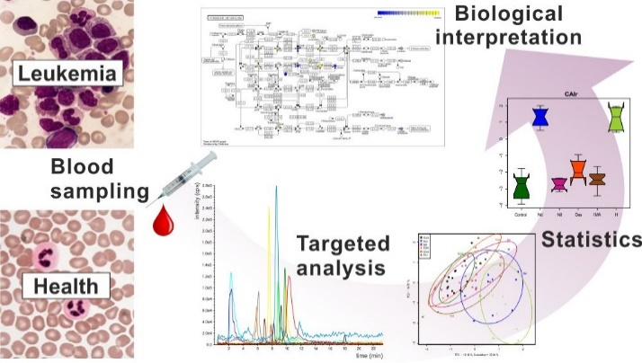
In chronic myeloid leukemia study, targeted LC/MS metabolomics method covering 350 metabolites was applied in order to understand biochemical changes of the disease(1). The metabolic profiles distinguished newly diagnosed patients and patients treated with hydroxyurea or tyrosine kinase inhibitors from healthy controls. The changes were found in glycolysis, citric acid cycle, and amino acid metabolism. Differences between resistant and well responding patients to imatinib treatment in levels of amino acids and acylcarnitines may be potentially used as an additional tool for the assessment of response.
In order to find new potential biomarkers of inborn errors of metabolism, untargeted LC/MS method allowing analysis of polar metabolites including phospholipids was used. Metabolic profile in dry blood spots from patients with medium chain acyl-CoA dehydrogenase deficiency was clearly distinguished from controls. Acylcarnitines (already well-known biomarkers) and oxidized phospholipids were found to be the most discriminating metabolites. Elevated levels of oxidized phospholipids in patients suggest an increased presence of oxidative stress as one of the pathophysiological mechanisms.

The work was supported by IGA_LF_2016_014, NPU I (LO1304), GACR I 1910-N26.

Reference
1. Karlíková, R. et al. Metabolite Profiling of the Plasma and Leukocytes of Chronic Myeloid Leukemia Patients. J. Proteome Res. 15, 3158–66 (2016).

